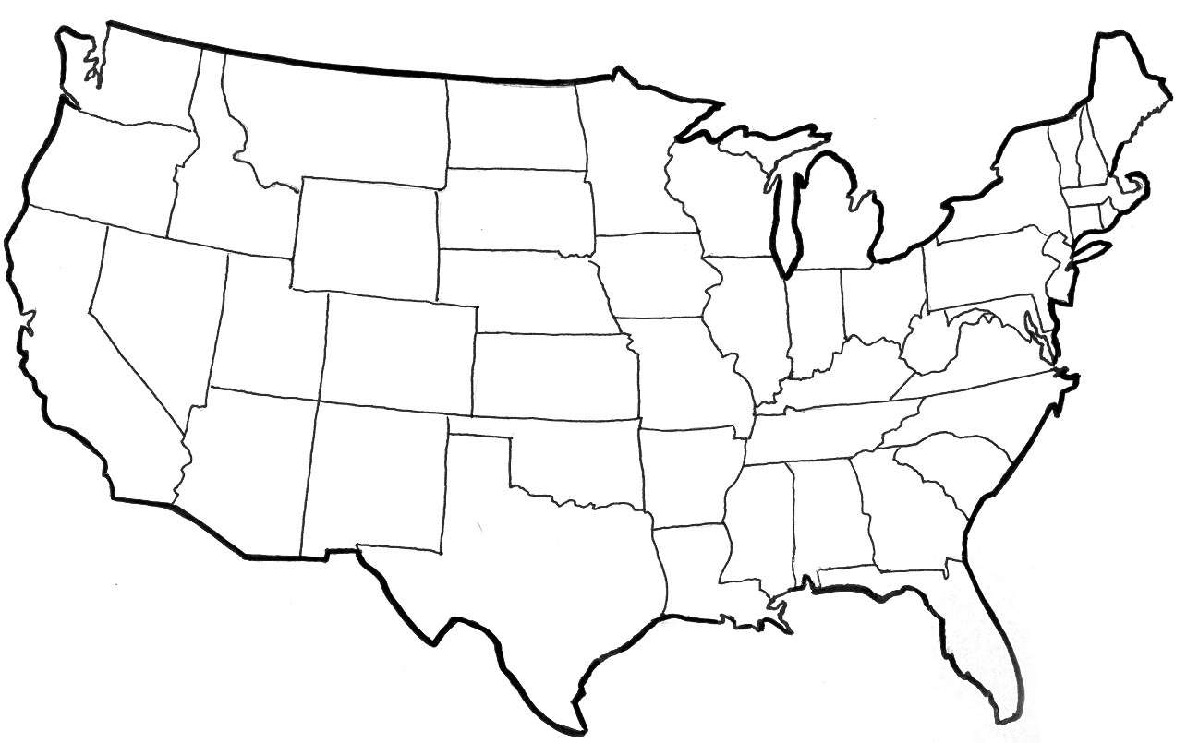
United States
Cities and Landforms Map

Directions: Use the text box below to label the cities and landforms on the map. Stars on the map represent cities. Use maps on page 240 or R56 to find the majority of the information.
Cities
Pittsburgh, Pennsylvania
Gettysburg, Pennsylvania
Kitty Hawk, North Carolina
Montgomery, Alabama
Man-made/Landforms
Chisholm Trail Grand Canyon
Salton Sea Mojave Desert
Great Salt Lake

